MTEch KE-4102 (ISBA) Project report

**ICT Short-Term Course RECOMMENDATION SYSTEM**

**TEAM MEMBERS**

NAME-1

NAME-2

NAME-3

NAME-4

MASTER OF TECHNOLOGY IN   
KNOWLEDGE ENGINEERING

BATCH KE-30(2018)

# 0.0 INDEX

**teAM MEMBERS**

Tang Shiyuan

Zhao xin

song yuhan

liu jun

Maddi kamal manishA

pedapudi venkata sai vijay kumar

MASTER OF TECHNOLOGY IN   
KNOWLEDGE ENGINEERING

BATCH KE-30(2018)

1.0 EXECUTIVE SUMMARY 2

2.0 PROBLEM DESCRIPTION 3

2.1 BACKGROUND 3

2.2 PROJECT OBJECTIVE 3

3.0 KNOWLEDGE MODELING 4

3.1 VIPS: VALUE 4

3.2 VIPS: INTERESTS 5

3.3 VIPS: PERSONALITY 6

3.4 VIPS: SKILLS 7

3.5 DEPENDENCY DIAGRAM 8

4.0 SOLUTION OUTLINE 9

4.1 SYSTEM SCOPE 9

4.2 UNIQUE FEATURES AND HIGHLIGHTS 10

4.3 ASSUMPTIONS 11

4.4 LIMITATIONS AND TRADEOFFS 11

5.0 CONCLUSION AND REFERENCES 12

5.1 CONCLUSION 12

5.2 REFERENCES 12

APPENDIX A: SAMPLE INPUT & SYSTEM OUTPUT 1

APPENDIX B: USER MANUAL 5

# 1.0 EXECUTIVE SUMMARY

ICT-SHORT Term Course Recommendation system. This system, "Activate your Life" is to recommend the current and prospective job seekers looking at Information and Communication Technology sector, Singapore with the job roles that best suits them along with the short-term course work they can consider taking up for gaining the required competency. Job groups like business analytics as well as related courses which are under NICF framework are covered in our system.

An Expert system is an intelligent system driven by data. Method of development includes modelling of domain expertise of a career advisor and the knowledge acquired through other online citations into rules which formed the intelligent part of our system. It's been found that VIPS (Values, Interests, Personality and Skills) are the crucial factors in rendering a career decision. Surveys has been conducted on target audience to gather the information on preferences made by people with different VIPS values. This result has been modelled (into decision tree) which formed the data part of our system. Symbolic AI with Forward rule chaining in CLIPS has been leveraged for building the core recommendation engine, which is integrated with .NET platform using C# for building a good user interface.

Categorizing jobs based on VIPS module is well known across many sectors but not so prominent in ICT sector. Our project addresses this implementation, because there has been an enormous growth in this sector which has opened new roles which requires work force with different personality types to handle them better. Recommendations which are aligned with user personality are deemed to be perfect as they gain good job satisfaction leading to mutual benefit to employer and employee.

# 2.0 PROBLEM DESCRIPTION

**2.1 BACKGROUND**

Demand for Information & Communication Technology (ICT) professionals in Singapore is high with an estimate of 42000 professionals in the coming 3 years. This surge in demand is due to emerging technologies such as AI (Artificial Intelligence), IoT (Internet of Things) and different industries leveraging the information technologies. Particularly among the workforce in Singapore, there is an observable upward tendency in the interest in Information Communications Technology (ICT) sector.

To accommodate the rise in interest and helping ICT companies in evaluating and bridging the skill gaps of their employees, IMDA (Workforce Development Agency) and Skills Future Singapore have developed the NICF (National Infocomm Competency Framework). Many course providers have been offering various courses following this framework. NICF courses are accredited by WSQ (Workforce Skills Qualifications) helping individuals gain certified competencies to achieve better work performance. People who are interested to improve their prospect and employability in ICT sector could take NICF certified courses to help them in securing a better position or transitioning from a different domain.

**2.2 PROJECT OBJECTIVE**

**Problem Statement and Objective**

Our target audiences are mainly adult learners and people with some working experiences, who are interested in having a better prospect in the ICT sector. To help interested individuals to secure a good prospect in this sunrise ICT sector, a clear and thoughtful guidance is required. The most common and straightforward way to start off is by taking relevant courses to gain the necessary knowledge. However, very often, when confronting with an unfamiliar job domain, a lot of time need to be invested to determine the 'job candidates' which are suitable to an individual. This process involves a lot of self-reflection, especially there are so many job function and job roles available. This system intends to provide a suitable direction to these individuals by recommending courses (from NICF course pool) and suitable job roles after analyzing information collected from users.

**Planning Towards the Objective**

* Understanding the ICT Domain in Singapore and the NICF framework.
* Identifying the scope of the project by finding our target audience and their needs.
* Web scraping course information and relevant job roles from NICF website.
* Developing our database from scraped information.
* Finding a suitable domain expert.
* Interviewing the domain expert to gain the knowledge.
* Knowledge elicitation through dependency diagram and inference diagram.
* Conducting survey based on the main factors identified to help generate a better solution.
* Generating rules and facts from our knowledge base.
* Build and validate the system.

**User Benefits of Using the System**

* Time: Recommending the career paths available to them through customized suggestions by saving the time of the user from a huge pool of jobs.
* Guidance: It has embedded intelligence to provide recommendations on the job roles in their interested field if they are in dilemma which is a common phase in anyone’s life.
* Effort: Providing them with the course information to achieve the competency for the suggested job along with the course providers information.
* This system generates results following the thought process of both a career advisor and a friend.

# 3.0 KNOWLEDGE MODELING

A powerful way to increase recommendation system’s performance is incorporating domain knowledge from an experienced domain expert [1]. After an interview with Dr. Yeo Wee Loon who is a professional career advisor working in Center for Future-ready Graduates at NUS, an interview graphical summary is depicted below. An analytical procedure has been developed which made our system flow. During the analyzing step, Values, Interests, Personality, and Skills called VIPS are major aspects concerned to make informed decisions. The interview graphical summary can be seen in Figure 3.0.1 and the concept dictionary is generated in Table 3.0.2.

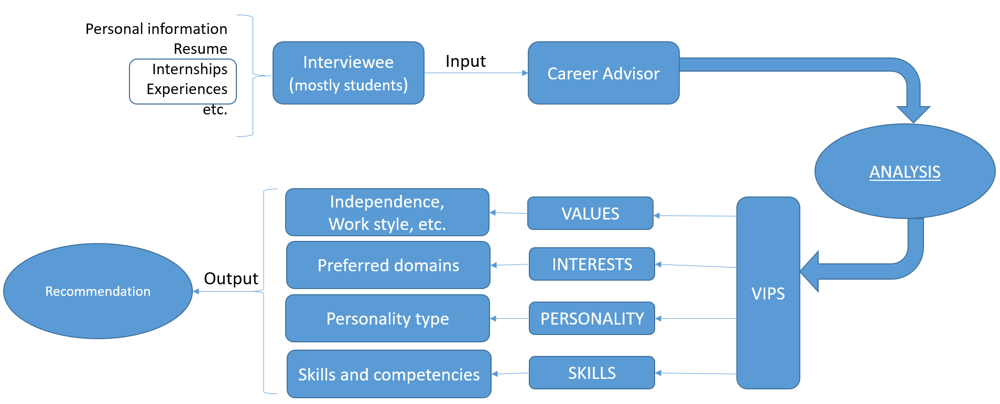

Figure 3.0.1: Interview Graphical Summary

|  |  |
| --- | --- |
| **Dimension** | **Focus of Assessment** |
| **Value** | Values are deeply held beliefs about what you must have in life or work. Like working style and challenging problems, etc. |
| **Interests** | Interests are things you like to do which are job groups in this system. |
| **Personality** | Personality is your way of doing things. This includes things like how do you make decisions? Do you prefer your time to be scheduled or spontaneous? |
| **Skills** | Skills are those things you do well. In this system, user’s level of skills regarding technical or managerial abilities is measured. |

Table 3.0.2: Concept Dictionary

Based on the above knowledge elicitation from the domain expert, we gathered more information from external written sources to further expand our knowledge base on the above VIPS methodology, which will be further discussed in the following sections. In addition, the collected survey data was utilized to generate a prediction model for ‘skills’, which will be discussed under ‘Unique Features’ in Section 4.

**3.1 VIPS: VALUE**

Satisfaction and success in career very much depends on whether one’s work and working environment align with his/her personal value.

Dr. Yeo (domain expert) also confirmed this and recommended a powerful analyzing tool: Knowdell Career Values Card Sort. It is created by Richard Knowdell who is a world-renowned career development expert. The usage is sorting cards into different stacks according to their importance. Then redo the sorting among all stacks to rank them again thus to find out few top values [2]. Altogether, there are 54 cards in a Knowdell Career Values Card Sort with 41 career values cards and the others auxiliary ones. Those 41 values are showed in the following Table 3.1.1 [3].

Knowdell Career Values Card Sort is designed to cater many domains. In our system, the number of frequently used values may be far less than 41 dues to our limited job varieties. It is too complex and not realistic to use all the 41 values. Based on jobs chosen in our system and their natures, high related values are picked and grouped accordingly (Figure3.1.2). From each group (column), the most representative value is picked. As for the second column, “Diversity” is named to represent the group. This recommendation system works for ICT domain, earnings of jobs suitable for an individual possessing certain competencies in this domain don’t very much. Therefore, values in the last column are ignored. To sum up, 3 values being “Challenging problem”, “Diversity” and “Working with others” are chosen for the system.

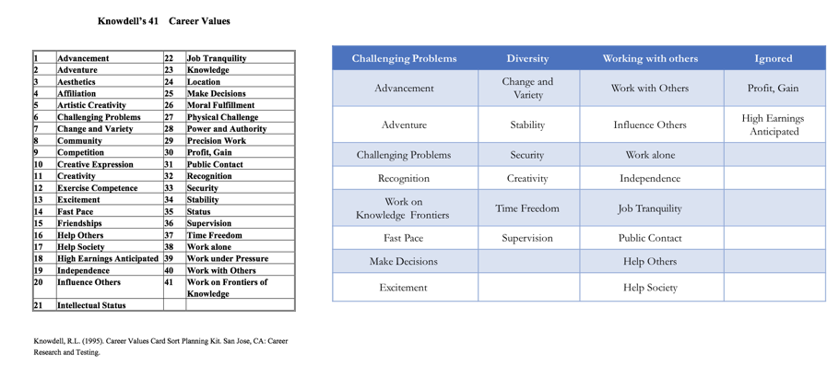 Table 3.1.1: Knowdell Career Values Figure 3.1.2 Chosen Values

Investigating into NICF job roles’ responsibilities and requirements, a link between values and jobs can be established. For example, job role of manager-statistics and mining in Business-analytics has following responsibilities. Each responsibility represents one or more values, and the one occurs most frequently is chosen to be the job’s value type. If there are equal numbers of occurrence of the values, the one coming first in responsibilities is assumed that more important one. According to these rules, this job role emphasizes more on “Working with others” than “Challenging Problems” and “Diversity” using newly created 3 values. So, it is more suitable for individuals who hold value of working with others. This matching structure is shown in the following in Table 3.1.3 below.

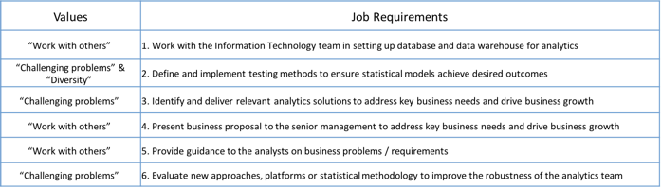

Table 3.1.3: Example of Choosing the Values for Certain Job

**3.2 VIPS: INTERESTS**

Interests can be a motivation thing in the career path. Once the job involves more interests of a person, it is more enjoyable for him/her to tackle difficult tasks and in turn better achievement can be obtained.

From NICF website, there are 26 job groups and each contains a list of job names. Altogether, there are 273 jobs according to our scrapped data using python. The 7 job groups are chosen in this recommendation system based on our survey result (showing in the pie chart below). This also aligns with the searching result of increasing popularity jobs from online sources. Descriptions of chosen groups are shown in Figure 3.2.1.

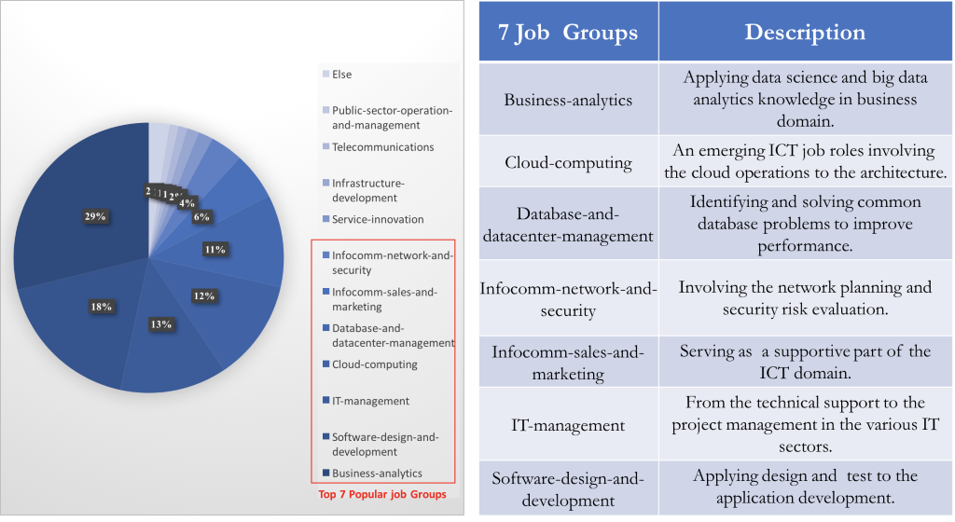

Figure 3.2.1: Job groups

Each job group contains different levels of jobs varying from entrant to senior management according to NICF definition. By analyzing and comparing requirements mainly in job description of different level jobs, the hierarchical order of the jobs is shown below in accordance to their work experience.

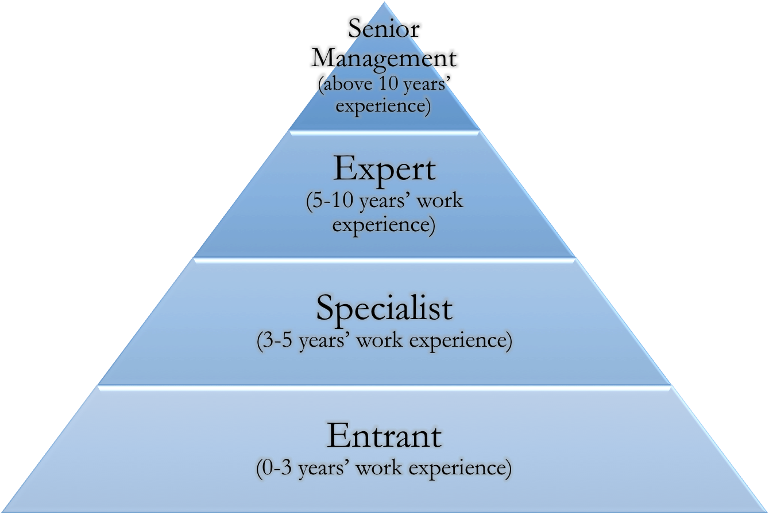

Figure 3.2.2: Job Hierarchy

**3.3 VIPS: PERSONALITY**

Personality matched occupations bring highest satisfaction because job engages individual’s strong personality traits. It is the way of a person doing things. Career which is in accordance to his personality helps him to excel. For example, a person with a preference for Introversion may find he or she is happier doing technical work or research, while a person who prefers Extraversion may favor a field with more interaction with people.

As mentioned by domain expert, the most frequently used instrument in the personality evaluation is the Myers-Briggs Type Indicator (MBTI) which contains four dimensional pairs for assessing personality types: extroversion (E) and introversion (I), sensing (S) and intuition (N), thinking (T) and feeling (F), judging (J) and perceiving (P). Combination of these elements total in 16 types of personality. Refer to MBTI type tables for occupations [4], link between 16 personality type and occupations can be established (see the table below). With reference to MBTI tables, mapping between our jobs and personality type is done by analyzing jobs' description to extract "Descriptive Words" and "Special Talent" (voting used here) in the table thus to link this job to its corresponding personality type.

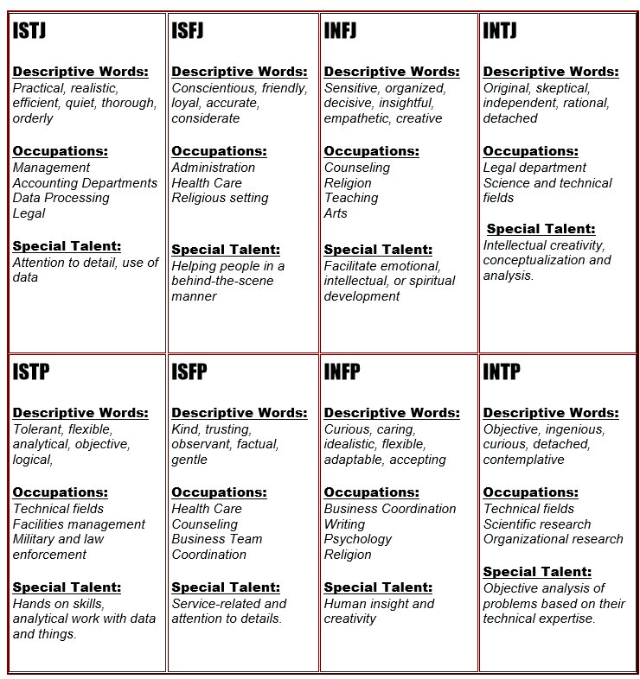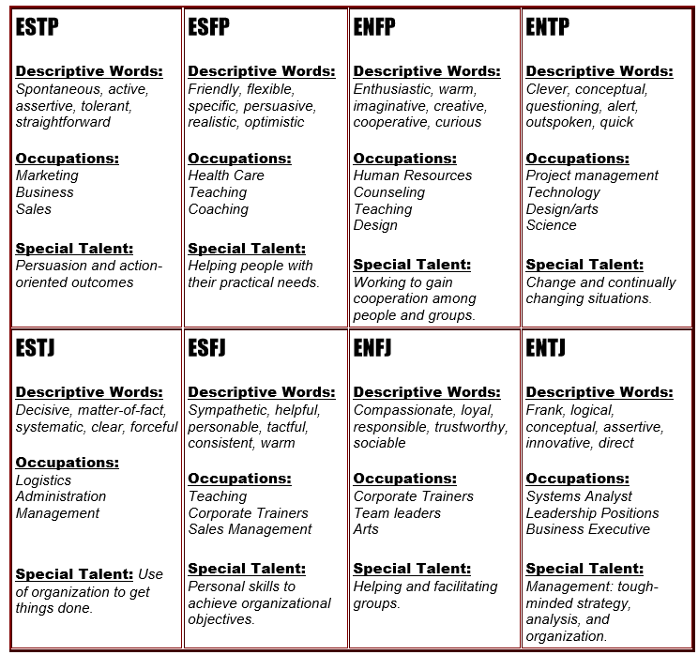

Table 3.3.1: Personality

**3.4 VIPS: SKILLS**

According to the domain expert, we could divide the skills which typical hiring managers look for into technical skills and transferable skills (also referred as soft skills). Especially trying to successfully transition into a different functional group or a domain, job applicants need to convince that they pose transferable soft skills. These transferrable soft skills include communication, teamwork, problem solving, conflict resolution and leadership skills that would accumulate over with working experience [4].

As described by our domain expert, when being confronted by a person seeking advices on his or her possibility to switch into a different domain, he would advise the person to think about both the technical and transferrable skill gaps between the person’s current and desired position. After identifying the skill gaps, the person would have a better idea of how and what should be done. This is in line with our approach since one of the most common ways for bridging any skill gaps is by attending courses.

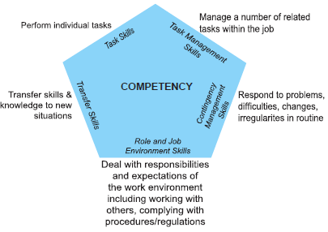The NICF is trying to achieve a similar goal when assigning a course difficulty level. The term which NICF uses is the ‘competency level’. The competency level is evaluated based on the 5 different skills illustrated in the diagram left [5].

It is mentioned in the competency document that this method stress more heavily on the occupational hierarchy and range and complexity of work items. Among the 5 types of skills highlighted, we could observe that task skills and transfer skills are more technically inclined, while the other three are inclined towards soft skills. It is straightforward to notice that work experience plays a main contributor to this competency dimensions as the framework is targeted towards adult learning.

Figure 3.4.1: Competency Level

Following the framework, competency is divided into 6 different levels and these levels generally could be mapped into different job levels [5]. This classification of competency level by job level is illustrated in Table 3.4.2 [6].

One of the main concerns in general when learners deciding choice of course is their ability to handle and understand the course materials [7]. It is critical to measure the current skillsets and skill gap of these learners to obtain a better outcome. For these individuals, it may be difficult to perform self-assessment on their own skillsets when they do not know ‘how to position themselves’ and ‘what to look for’. The course selection process could be time consuming when trying to search for a suitable course difficulty due to this hesitation. The respective information to be obtained from users as a representation to the latent factors of 'skills' is shown in Table 3.4.3.

|  |  |
| --- | --- |
| **Job Level** | **Competency Level** |
| **Operations** | Level1 and 2 |
| **Supervisory** | Level 3 |
| **Managerial** | Level 4, 5 and 6 |

|  |  |
| --- | --- |
| **Information**  **(X- variables)** | **Latent Factor** |
| **Work experience** | Soft skills |
| **IT skills** | Technical skills |
| **Current and Preferred/Desired Job Nature** | Skill gap |

Table 3.4.2: Job Mapping

Table 3.4.3: Latent factor mapping

**3.5 DEPENDENCY DIAGRAM**

A dependency diagram of recommendation system is drawn based on our knowledge modeling process. Competency is derived from the bottom nodes work-experience, IT-Skills, current job information, and preferred job information. It is a bottom-up structure with four top-most critical factors being job groups, competency, personality and value which decides the recommendation output.

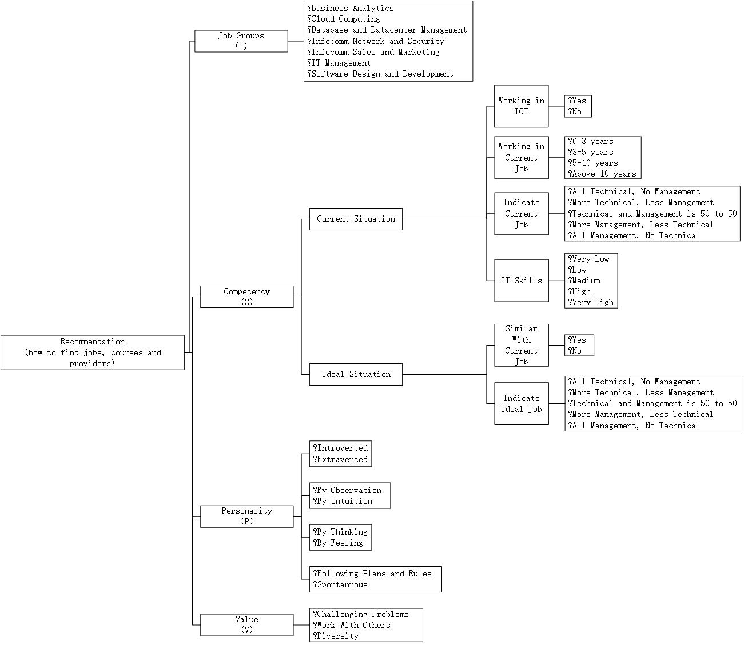

Figure 3.5.1: Dependency Diagram

# 4.0 SOLUTION OUTLINE

**4.1 SYSTEM SCOPE**

The following diagram shows our system structure. This is a windows application, which is built on .NET platform using C#. CLIPS being the main recommendation engine, it’s been integrated with C# program and we have leveraged the provided visual studio windows to construct our user interface.

Rules fired in the clips form the questions and recommendation to users on UI. In our case, all the jobs, courses details have been stored as Facts in CLIPS which formed our database. And based on users input, corresponding rules would be triggered leading to Final Recommendation.

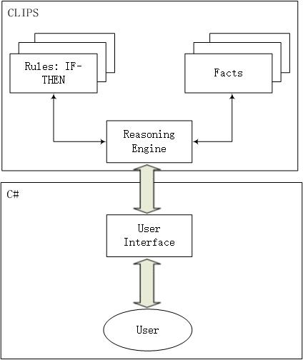

The scope of system involves the following tasks:

1. Collect user information through selecting several options to be a specified case.
2. Classify the case's value and job group. (Seven job groups and three values have been defined in our system.)
3. Calculate (prediction model) competency level from the case's work experience, IT-Skills proficiency, current and preferred job.
4. Match the case's personality attribute, which combines four parts, the system can get the most suitable personality attribute it has through matching these four parts one by one and returning the value with the most matches.
5. Aggregate the results (user profile), match CLIPS rules to get the recommended jobs and read courses and provides of these jobs from dataset.
6. Display the best result.

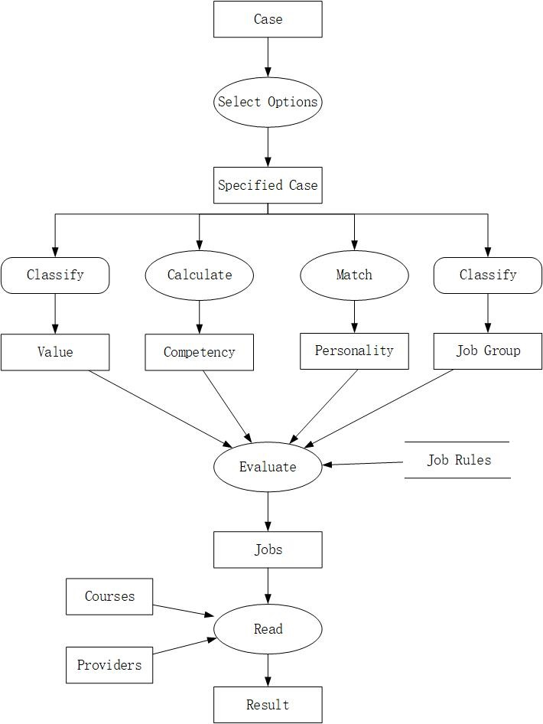Figure 4.1.1: System Structure Diagram

**while** **new-solution** specify (case-description -> specified-case) **do**

case-description := specified-case;

**end while**

classify (specified-case -> value);

calculate (specified-case -> competency);

match (specified-case -> personality);

classify (specified-case -> job-group);

**repeat**

select (job-rules -> selected-rule);

evaluate (value + competency + personality + job-group + selected-rules -> jobs);

**until has-solution** read (jobs + courses + providers -> result);

Figure 4.1.2: Inference Diagram

**4.2 UNIQUE FEATURES AND HIGHLIGHTS**

**Decision Tree Prediction Model for Course Difficulty (NICF Competency Level)**

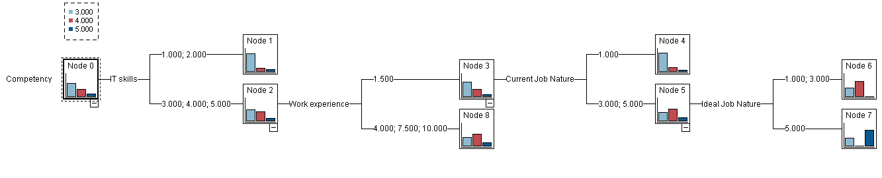We decide to incorporate a prediction model into our system to predict a suitable course difficulty level in the backend. To help with building this prediction model, a survey was done by collecting the background information of individuals consisting latent factors of ‘skills’ as mentioned in Table 3.4.3 (X-variables) and the course difficulty that they are confident in (Y-variables). With the survey results, a model is constructed based on C5 decision tree algorithm.

Figure 4.2.1: Inference Diagram

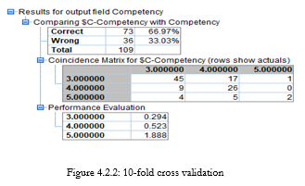10-fold cross validation was done with the total 109 survey responses and a model accuracy of 67% was reported. This result goes along with good reasoning. For those with low IT technical skills, we assign a difficulty level of 3. For those with high IT skills, we look for work experience and generally could assign a course difficulty of level 4. Else with lesser working experience, we would need to consider the skill gap between the current and desired job nature. This model is written into CLIPS by converting the decision tree to a set of rules.

**Providing the Next Best Matches**

From our domain understanding, ‘Personality’ is a relatively weak indicator for the suitability of a person in each job roles. As even though the personality may not match well with the intended job roles, people tend to perform better even if the required job role doesn’t fit into their personality. For instance, an introvert like Obama is a good public speaker which goes against the regular way. A best scenario with result that matches the 'Personality' would be a perfect match of 4 dimensional pairs which we discussed in Section 3.3. When there is no exact match of result due to ‘Personality’, the system would try to find the results of matches with 3 dimensional pairs. If no results were found, they system will proceed to matches with 2 dimensional pairs, and finally 1 pair. Following this logic, the next best matches would be output by the system. If still no results were found, an empty result will be returned by CLIPS (data not available in our database) and our system will proceed with a next contingency plan.

**Data Deficient Proof**

Following the scenario above, when CLIPS returns an empty result to the UI, it is considered that our database is deficient of data (no suitable course matches well with the user regardless of the ‘Personality’. This is done by utilizing CLIPS’ rule activation strategy. New fact is asserted into the working memory when CLIPS returns an empty result to the UI. For example, if no results were found with competency 3, the system would assert new fact of competency 4 into CLIPS. At this point, both facts of competency 3 and competency 4 are available in CLIPS’ working memory. If then a match were found, the rules which activated by competency 4 fact would be fired. If still empty result were returned, new facts will again be asserted following the priorities below:

IF there is no result for this case THEN

IF there is not result for all cases of the same value THEN

Change value type to the next one

ELSE

Change competency to the next one

ENDIF.

ENDIF.

A result is guaranteed to be found following this new-fact assertion method and thus full-proofing possible data deficient of system. If this contingency plan were activated, the user is informed that it is not a best match.

**4.3 ASSUMPTIONS**

|  |  |
| --- | --- |
| **Perspective** | **Assumptions** |
| **Target audience** | 1. They are adult learners and already attained some form of higher education (minimum of a diploma degree). 2. They are interested in ICT regardless of their motivation. Whether their goal is driven by the interest of switching career domain, functional role, or purely enhancing their skills, the course selection pool only contains courses that resulting learning outcome could be applied in ICT sector. 3. They are eager to learn as an individual and the decision of searching for courses is self-initiated, and not due to any company sponsorship and requirements. |
| **Course fee** | 1. The influence of course fee in an individual’s decision-making is neglected. |
| **Course difficulty** | 1. Only 5 levels of course difficulty were used as survey options instead of 6 levels since the number of level 6 courses is low and are not in our course selection pool. 2. Survey data on observations with low confident level (difficulty of 1 & 2) are mapped to course difficulty (competency) of 3. This is done because majority of our survey participants are ISS master students and our system’s target audience are assumed to have diploma-level qualifications. Observations that select low course difficulty level is treated as noise. |

Table 4.3.1: Assumptions

**4.4 LIMITATIONS AND TRADEOFFS**

|  |  |
| --- | --- |
| **Limitations** | **Elaborations** |
| **Classification accuracy of attributes of job roles** | 1. Specific ‘Personalities’ and ‘Values’ are assigned to job roles. This process is often subjective and there are limited resources to differentiate these attributes clearly for specific job roles within the same ICT domain. 2. Voting is done within team members to improve the overall accuracy of this manual classification procedure. |
| **Accuracy of prediction model due to survey population** | 1. Survey participants are taken from ISS master students, which became the sole representative sample of the whole target audience population (much larger). 2. The accuracy of prediction model for a suitable course difficulty could vary if another population appears which behaves differently with our survey population. 3. Ideally, survey participants should be the actual course participants. Unfortunately, there are huge difficulties in obtaining these data. |
| **Accuracy of latent factor measurement** | 1. We only used one or two background information from users to represent each skill latent factors. In reality, there are many more attributes to be obtained from users to have a better accuracy on measuring the intended latent factors. |

Table 4.4.1: Limitations

# 5.0 CONCLUSION AND REFERENCES

**5.1 CONCLUSION**

**Learning Outcomes**

* How to survey different Citations to build a domain understanding. In our case we have formed an information base from the online resource NICF and to scrap the information required from website.
* Interviewing Skills i.e., to capture how a domain expert approaches a problem and get the tacit knowledge which he has acquired through experience.
* Surveying Skills i.e. what statistics to capture from targeted users and how to model the result of survey. In our case we have come up with a decision tree which is discussed in the Unique Feature Section. This formed the data part of our system.
* To come up with an Inference diagram and formulate rules using the information obtained from interview and survey.
* To code the obtained rules in CLIPS and integrating it with C# in .NET for a good user interaction.

**Improvements to Our System**

* Our present system analyzes the users work experience in ICT or NON-ICT sector, his current job nature and the job nature he prefers. We have employed VIPS method to understand the user better for providing a better suggestion. However, the user can be improved when we get to know his exact skill-set and his proficiency in them. This enables us to find a better job-match or short-term course.
* Our system scope is limited to only ICT sector, but this can be extended to different sectors as we capture most of the user’s attributes, preferences and analyze to recommend a job.
* In case of domain shift, more insight such as what made him to choose the new sector, his understanding on the new sector must be drawn before rendering a choice. This requires a psychological analysis on the person as per domain expert. This analysis can be embedded in the system to make it more interactive.

**5.2 REFERENCES**

[1] Fensel, D. (2000). Problem-Solving Methods: Understanding, Description, Development and Reuse. Springer.

[2] Knowdell, R.L. (1995). Career Values Card Sort Planning Kit.

[3] MBTI Type Tables for Occupations by Nancy A. Schaubhut and Richard C. Thompson (CPP 2008).

[4] Bortz, D. Monster Worldwide Inc. Soft skills to help your career hit the big time, accessed 1 Mar 2018, <<https://www.monster.com/career-advice/article/soft-skills-you-need>>.

[5] Singapore Workforce Skills Qualifications. (2006). Interpretation of WSQ Competency Standards for Training and Assessment.

[6] Skills Future SG. (2016). Singapore Workforce Skills Qualifications. Employability Skills Competency Map.

[7] Sabell, H. (2017). The College of Adult Learning. Top Common Concerns of Adult Learners, accessed 1 Mar 2018, <[https://collegeforadultlearning.edu.au/top -common-concerns-of-adult-learners/](https://collegeforadultlearning.edu.au/top-common-concerns-of-adult-learners/)>.

# APPENDIX A: SAMPLE INPUT & SYSTEM OUTPUT

In our recommendation system, different jobs are mapped with their corresponding core values, Mayer's Brigg Characteristics and the competency levels as below:

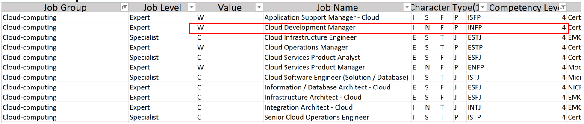

In the above is one for a Cloud Development Manager with the fourth level competency, the personality type is INFP and likes working with others, which forms the value of job (natation is W). Competency level is based on several parts, includes work experience, IT skills, current and preferred/desired and job nature, like we have explained above.

**Sample 1**

This is a “standard” case, in this case, we will show how to fire different rules in our CLIPS with user’s input and give the most suitable recommendation according to it.

1) At the first screen, it fires the “system-banner” rule in our CLIPS, giving the welcome message at screen and initialize the whole system.

2) After clicking “Next >” button, the “QUERY RULES” part in our CLIPS will be fired according to what need to be asked next, and print out every question and its options. The choice of every question is as below:

|  |  |  |  |
| --- | --- | --- | --- |
|  | No. | Questions | Options |
| Skill | 1 | Have you been working in ICT domain? | Yes |
| Interest | 2 | Which following job groups are you interested in? | Cloud Computing |
| Skill | 3 | Is that same/similar with your current job? | Yes |
| 4 | How long have you been working in your current job? | 3-5 years |
| 5 | Can you indicate your current job nature? | More Technical, Less Management |
| 6 | Can you indicate your ideal job nature? | More Management, Less Technical |
| 7 | What is your current IT related skills? | Medium |
| Value | 8 | What do you value most? | Work with Others (W) |
| Personality | 9 | What is your mind types? | Introverted (I) |
| 10 | How do you see things? | By Intuition (N) |
| 11 | How do you judge things? | By Feeling (F) |
| 12 | How do you usually act towards changes? | Spontaneous (P) |

3) When user has finished the question part, our system will classify value and job group of the user, calculate competency with user’s choice of question 1, 3, 4, 5, 6 and 7, match personality with the choice of question 9 to 12. And then, the “RECOMMENDATION RULES” part will be fired to recommend the most suitable jobs, courses and providers.

For this case, the user’s job group is cloud computing, value is W, competency is 4 and personality is INFP, so the recommended job is “Cloud Development Manager”, courses are “Certified Cloud Computing Professional (CCCP)” and “Certification in IT Project Management (CITPM)”, and the provider of course is “Global Science and Technology Forum Pte Ltd” and “COMAT Training Services Pte Ltd respectively”.

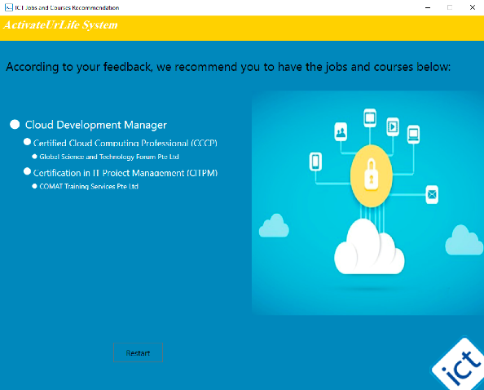

4) If user wants to find more information of the result, he/she can click the result directly and jump to the NICF website, which gives more detail description of jobs and courses, or jump to the official website of providers. Below is an example of the job above.

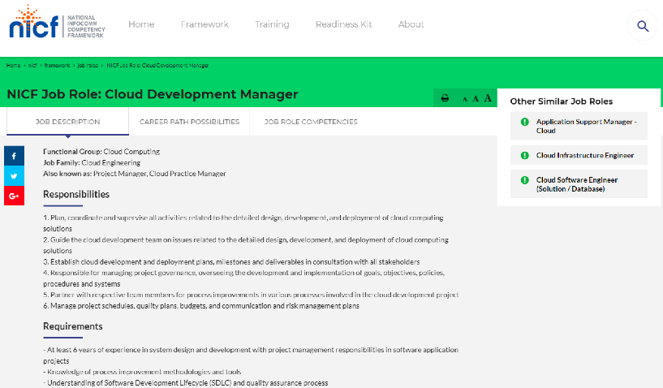

**Sample 2**

This case corresponds to demonstrating the feature of ‘providing next best match’ of our system (discussed in Section 4.2). This case is about how to match personality attributes from the user inputs and how to deal with the situation that cannot match exactly. Under a job group which the user chooses, based on his/her personality inputs, if there is no exact match, from the four personality attributes given by the user our system would be searching for the job with the nearest attribute match. This has been suggested by our Domain Expert.

For example, if the user’s inputs are as below:

|  |  |  |  |
| --- | --- | --- | --- |
|  | No. | Questions | Options |
| Skill | 1 | Have you been working in ICT domain? | Yes |
| Interest | 2 | Which following job groups are you interested in? | Database and Datacenter Management |
| Skill | 3 | Is that same/similar with your current job? | Yes |
| 4 | How long have you been working in your current job? | 0-3 years |
| 5 | Can you indicate your current job nature? | All Technical, No Management |
| 6 | Can you indicate your ideal job nature? | More Technical, Less Management |
| 7 | What is your current IT related skills? | Medium |
| Value | 8 | What do you value most? | Challenging Problems (C) |
| Personality | 9 | What is your mind types? | Introverted (I) |
| 10 | How do you see things? | By Intuition (N) |
| 11 | How do you judge things? | By Feeling (F) |
| 12 | How do you usually act towards changes? | Following Plans (J) |

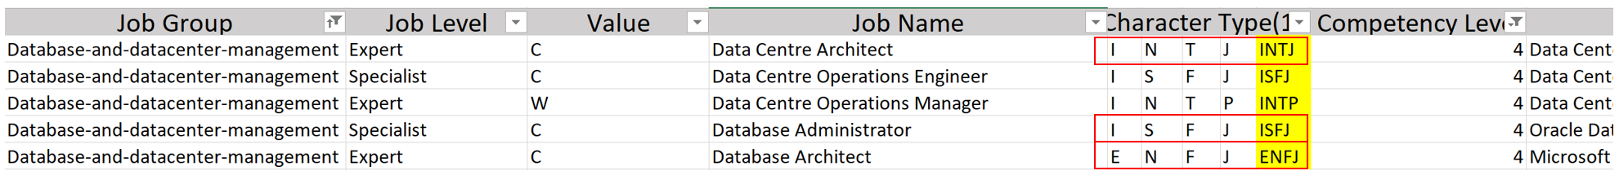

We could see from the database snapshot above, there is no ‘Personality’ which matches ‘INFJ’

From the above input, the personality attributes correspond to INFJ, the competency level is 4 and the value that user choose is Challenging Problems. There is no exact match for this case, because our system only has three personality attributes, which are ENFJ, INTJ and ISFJ. And our system will recommend the results of ENFJ and ISFJ (3 pairs of personality dimension matches), after comparing those four personality groups one by one (I/E, N/S, T/F and P/J), because ENFJ and ISFJ are the most similar personality attributes with user’s choice, which has three dimension pairs are the same.

For this case, the output likes below:



**Sample 3**

This case corresponds to demonstrating the ‘data deficient proof’ of our system (discussed in Section 4.2). This case is about how the competency calculated from the user inputs using the logic discussed in the above sections and how to recommend when system cannot find a result with the user’s personality attributes, value and the job group he/she choose.

The choice of every question if as below:

|  |  |  |  |
| --- | --- | --- | --- |
|  | No. | Questions | Options |
| Skill | 1 | Have you been working in ICT domain? | Yes |
| Interest | 2 | Which following job groups are you interested in? | Infocomm Sales and Marketing |
| Skill | 3 | Is that same/similar with your current job? | Yes |
| 4 | How long have you been working in your current job? | Above 10 years |
| 5 | Can you indicate your current job nature? | Technical and Management is 50 to 50 |
| 6 | Can you indicate your ideal job nature? | All Management, No Technical |
| 7 | What is your current IT related skills? | Medium |
| Value | 8 | What do you value most? | Challenging Problems (C) |
| Personality | 9 | What is your mind types? | Extraverted (E) |
| 10 | How do you see things? | By Intuition (N) |
| 11 | How do you judge things? | By Feeling (F) |
| 12 | How do you usually act towards changes? | Following Plans (J) |

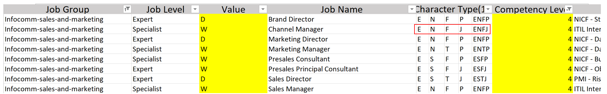

We could see from the database snapshot above, there is no Value that matches ‘Challenging Problems’. With this case, there would be no match even if changing ‘Personality’.

1) For the competency calculating, it follows the decision tree explained above, in this case, user’s IT skills is marked 3 and work experience is marked 10, so one of branch of the decision tree explained above will be matched and the competency is 5.

2) We have 7 job groups, 3 competency level, 3 value types and 16 personality types, it means if our system can cover all cases, giving different result for different case, it should 1008 records at least. But it only has 100 records now, so when our system cannot find a result for some cases, it will give some other recommendation through changing competency level and value type.

In this case, user’s competency level is 5 and value type is Challenging Problems (notation is C), after firing rule of this case, no result exists and then our system will change some values with the logic explained above.

According our system logic, our system will attempt to assert new ‘competency fact’ with a different value, i.e. assert ‘competency level 4’. If no results were found, the system would assert ‘competency level 3’. This leverages the advantages of CLIPS, where old facts are still in the system.

After exhausting the ‘competency’ option, our system changes user’s ‘value’ type to “Working with Others (W)”, and start from ‘competency 5’ again. But then our system finds there is also no result for value type “Working with Others” and competency 5, so it changes user’s competency level again, from 5 to 4. Similar logic continues until a result is obtained. This guarantees an output where often in real life cases, we do not have a complete database matches all the combinations of attributes.

After finding the final result, our system will notify the user with the message “Sorry! We cannot find the most suitable results according to your feedback, but we still recommend some other jobs and courses that may be suitable for you” to inform the user. For this case, the output likes below:



# APPENDIX B: USER MANUAL

The executable along with required libraries would be provided as a zip file which can be downloaded and extracted. The exe file is present in the bin folder which can be run. Upon running it, the user would be provided with a UI which can be navigated like below.



When user click the “Next >” button, a few questions will be asked in order to have an accurate recommendation about jobs, courses and providers of these courses. The first question is “Have you been working in ICT domain?”.

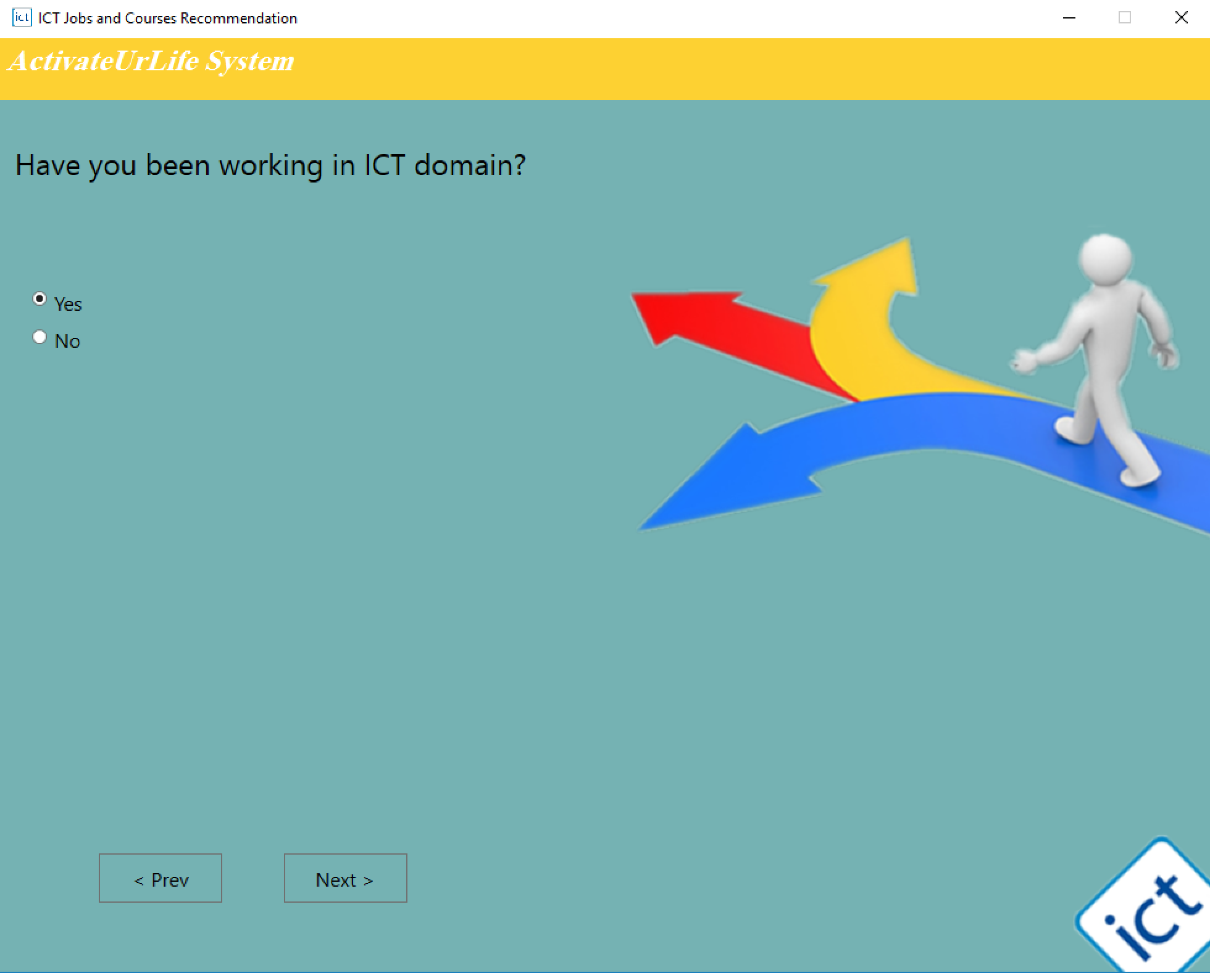

After choosing, user should click “Next >” again or click Return button, and next question will show, which is “Which following job groups are you interested in?” with seven options and the user has to choose the group which he is interested in.

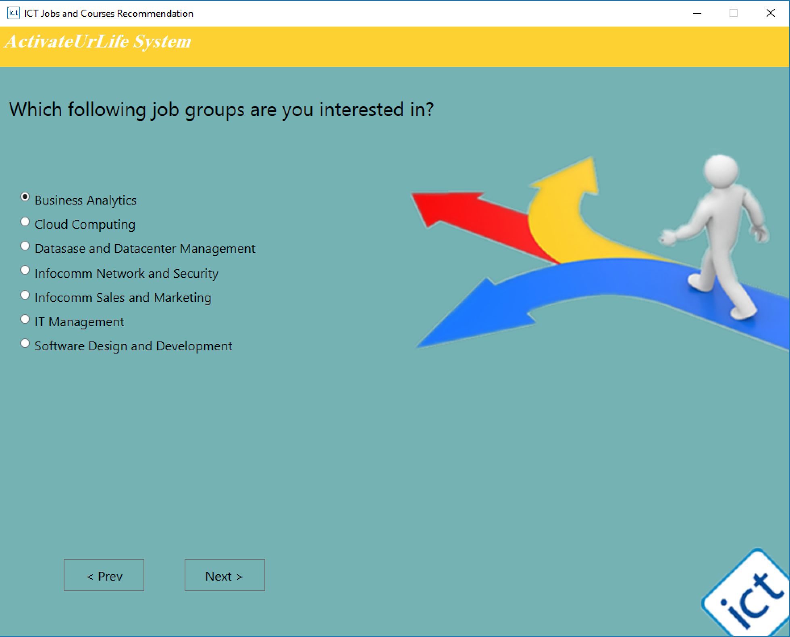

The third question is “Is that same/similar with your current job?”, it follows use’s answer of the second question. User should help us to identify whether they have prior work experience or their current domain is same as their previous choice with the options “Yes” and “No”.

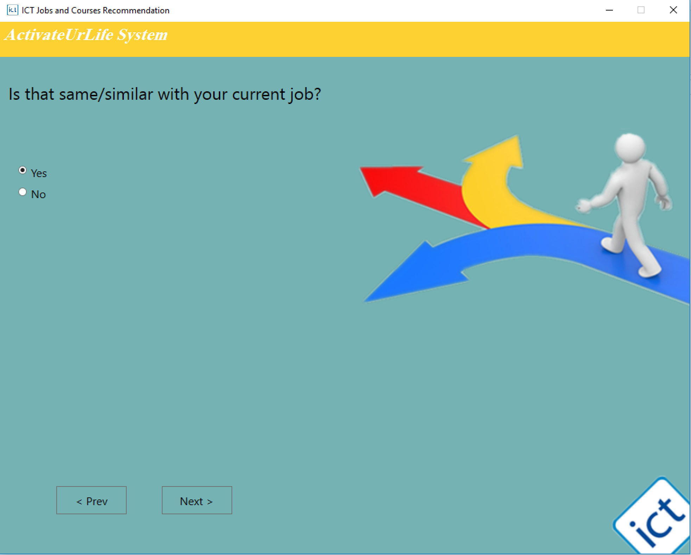

Next question is about user’s working experience, which is “How long have you been working in your current job?” we have divided it into four parts, and user should choose one option according to their current situation.



The following two questions are about indicating user's current and ideal job nature. We define it through the percent of technical and management job user want to have in their job.

 

The seventh question is about user's current IT related skills, from low to high.

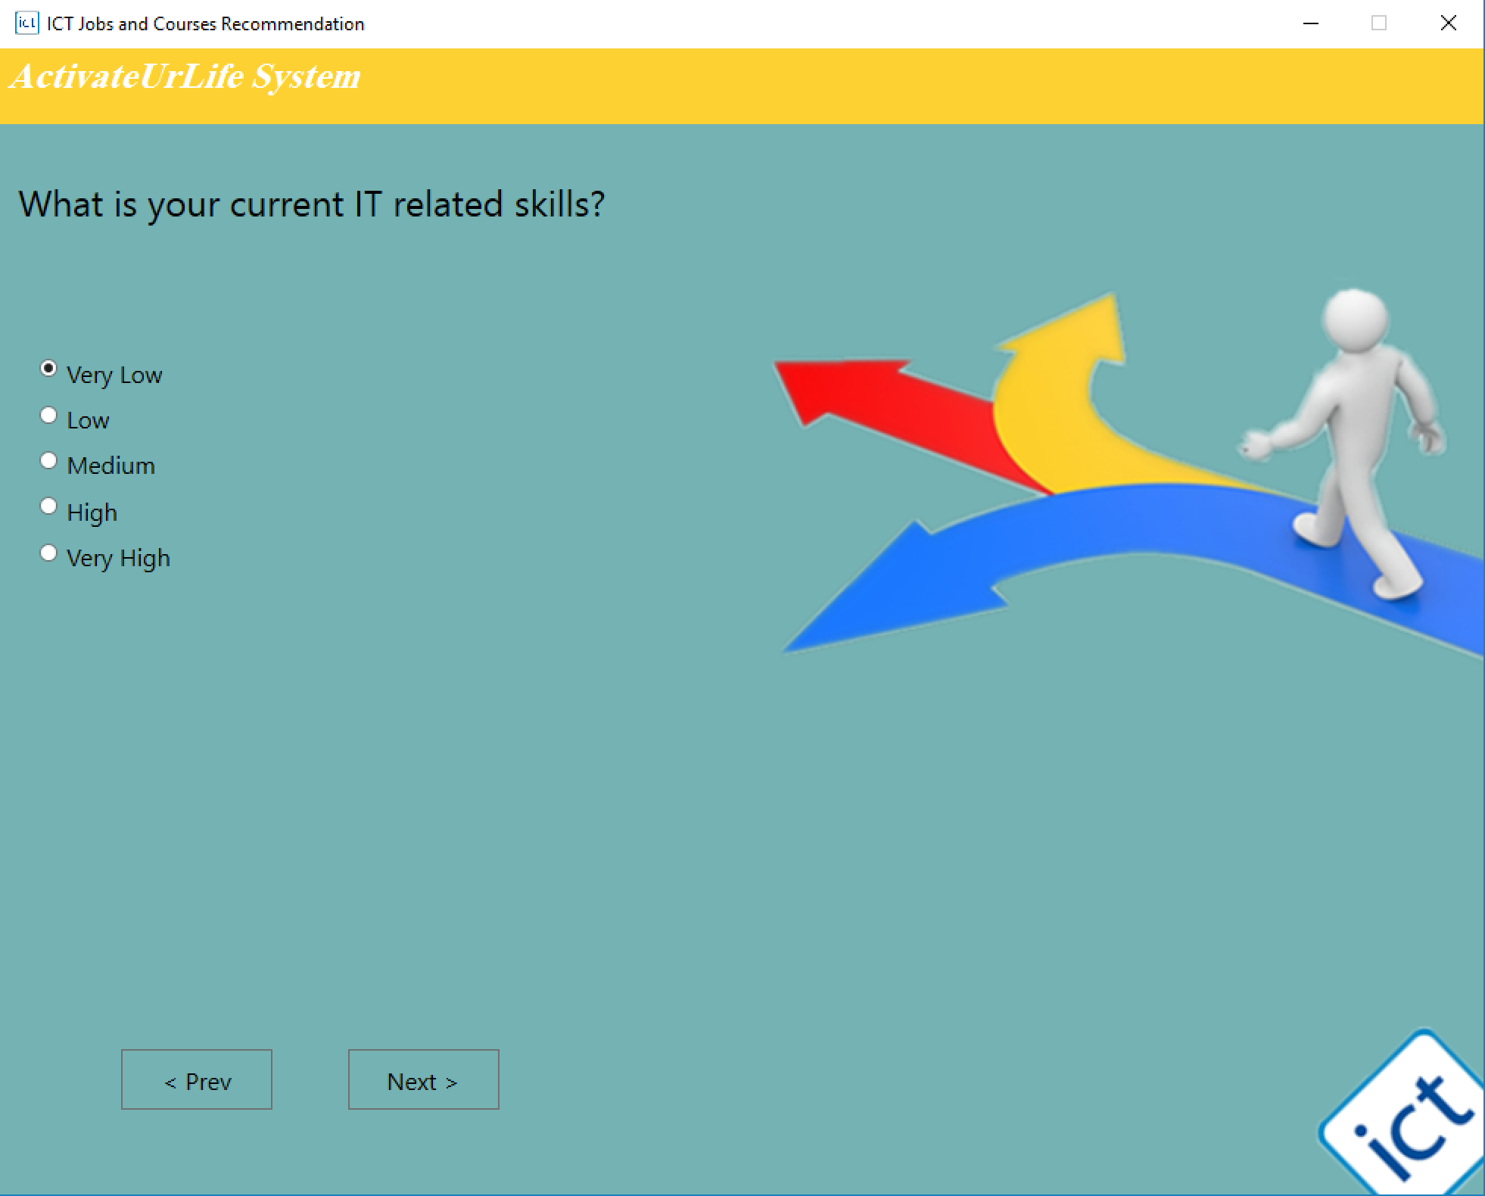

This one is to understand which kind of value do the user like most.

Challenging Problems means engaging continually with complex questions, trouble shooting and problem solving as part of core job.

Working with Others means like working closely in teams for a single goal.

Diversity means prefer to work in a settling that includes people from different social background.

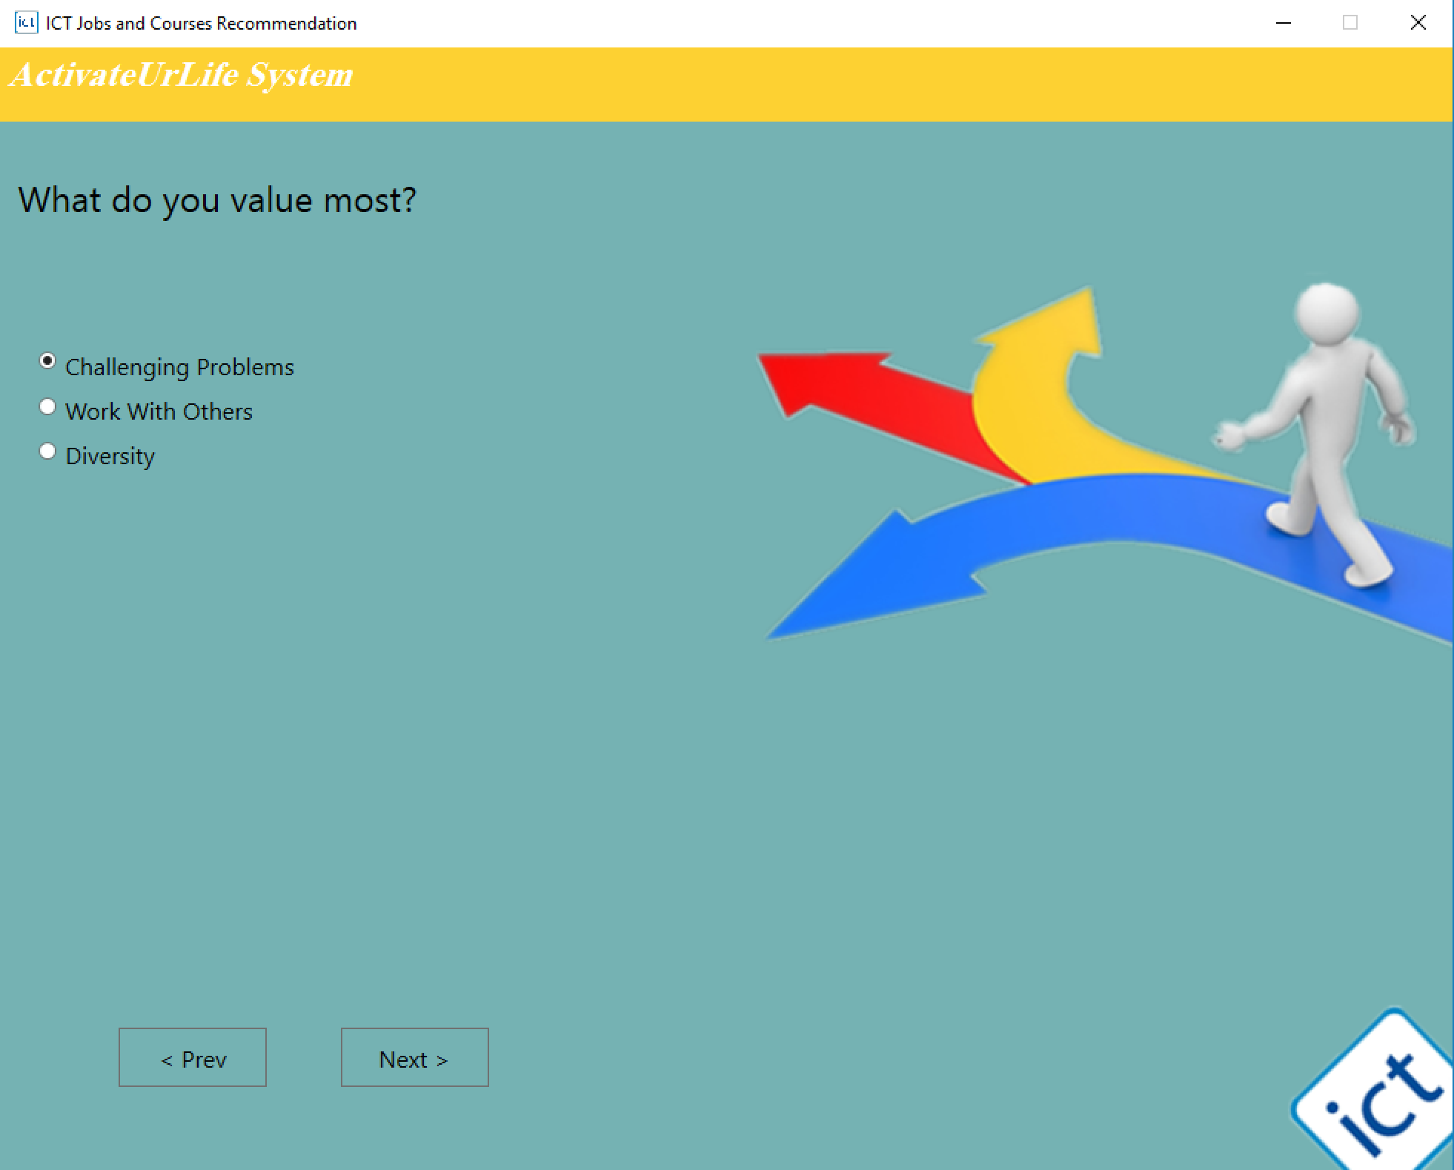

The following four questions is help the system to have a good understanding of user’s personality, includes Introverted/Extraverted, By Observation/By Intuition, By Thinking/By Feeling, Following Plans/Spontaneous.

Introverted: It’s a deductive type of reasoning trying to explain logical problems with subjective information.

Extroverted: It’s an inductive type of thinking which places information such as facts in higher order.

By Observation: More focused on facts and observable things.

By Intuition: Focusing more on the idea and vision.

By Thinking: Taking decisions based on logical principles and objective truth.

By Feeling: Feeling types place an emphasis on issues and causes that can be personalized while they consider other people's motives.

Following Plans: Judging types will thrive when information is organized and structured, and they will be motivated to complete assignments in order to gain closure.

Spontaneous: Perceiving types will flourish in a flexible learning environment in which they are stimulated by new and exciting ideas.

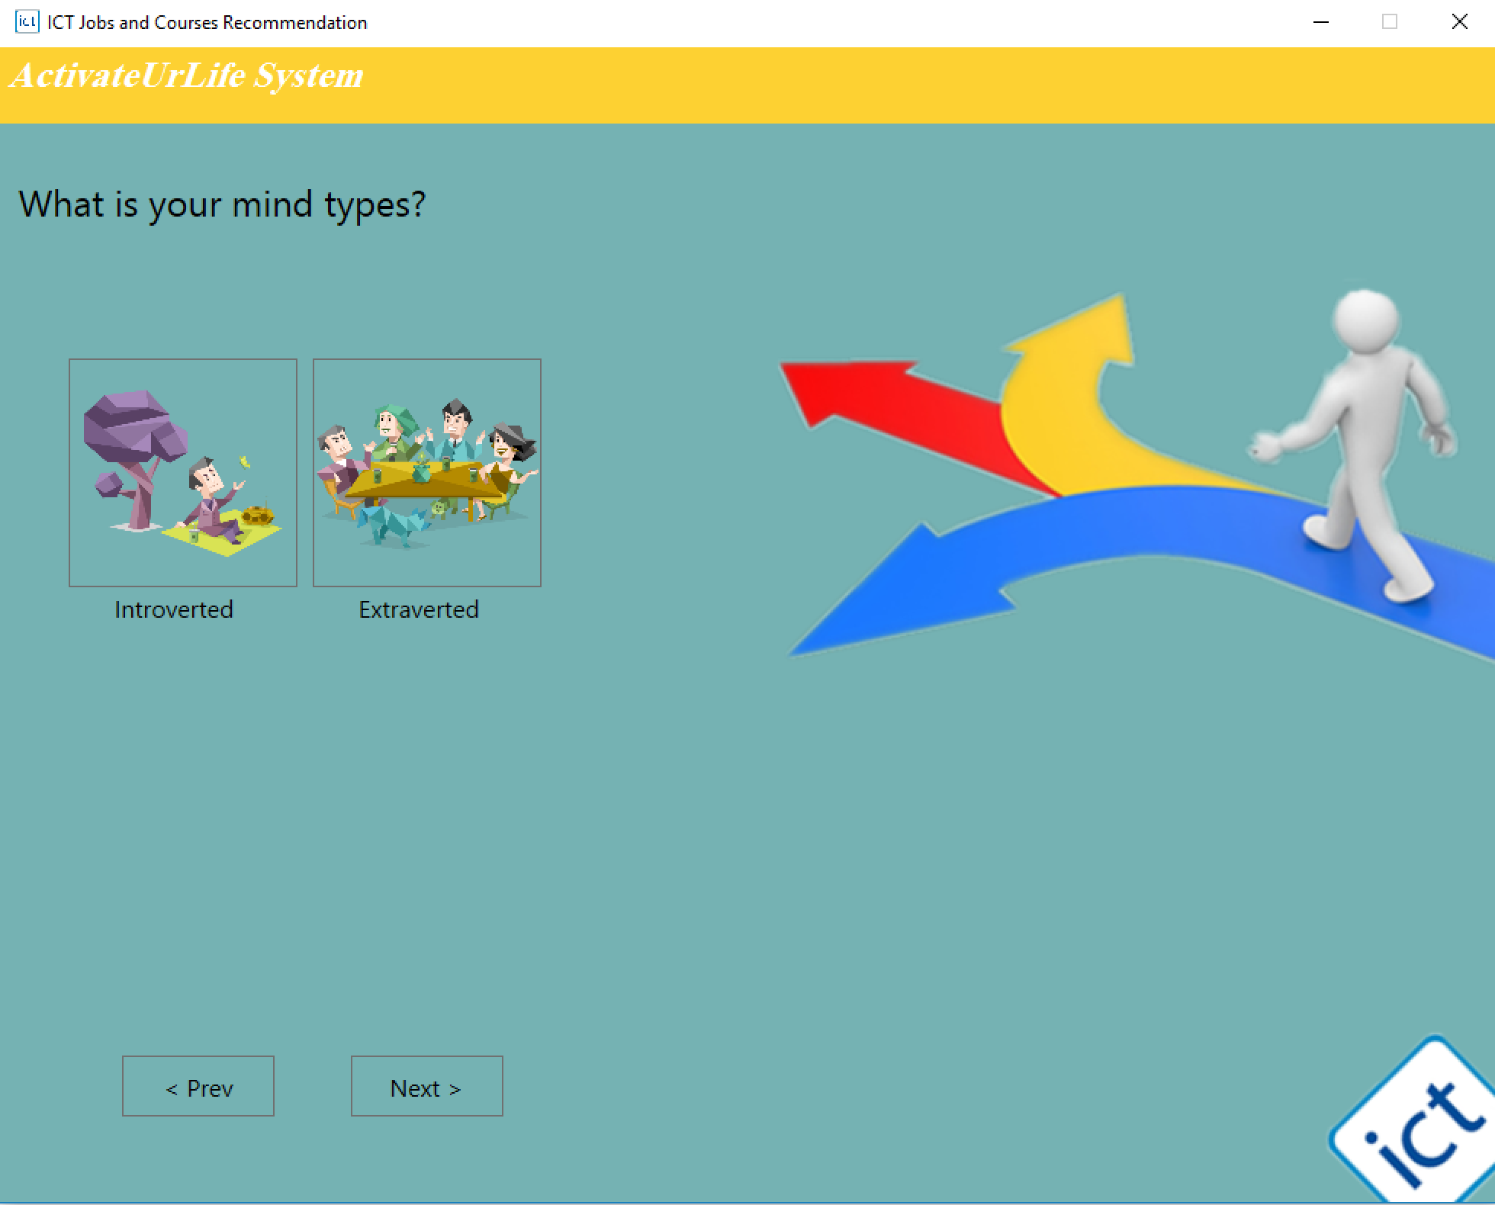 

 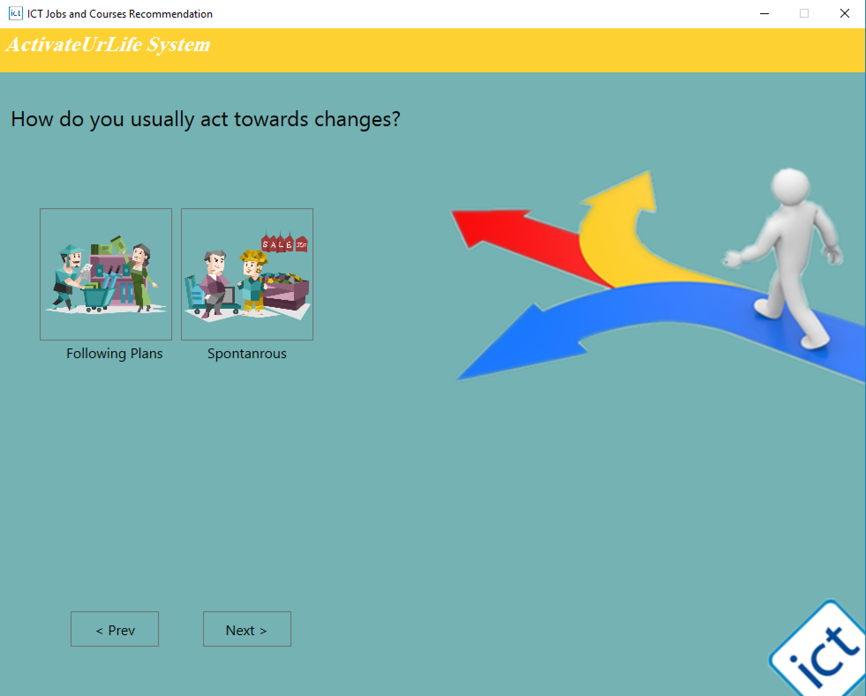

After finishing those questions, user can get the result of recommendation. The system will match all rules it has and give the most reasonable output to user, which includes one or several jobs, some courses related to these jobs, and one provider of every course.



User can click the result and system will link directly to the detail description of these jobs and courses in NICF, and the official website of these providers.

For job:

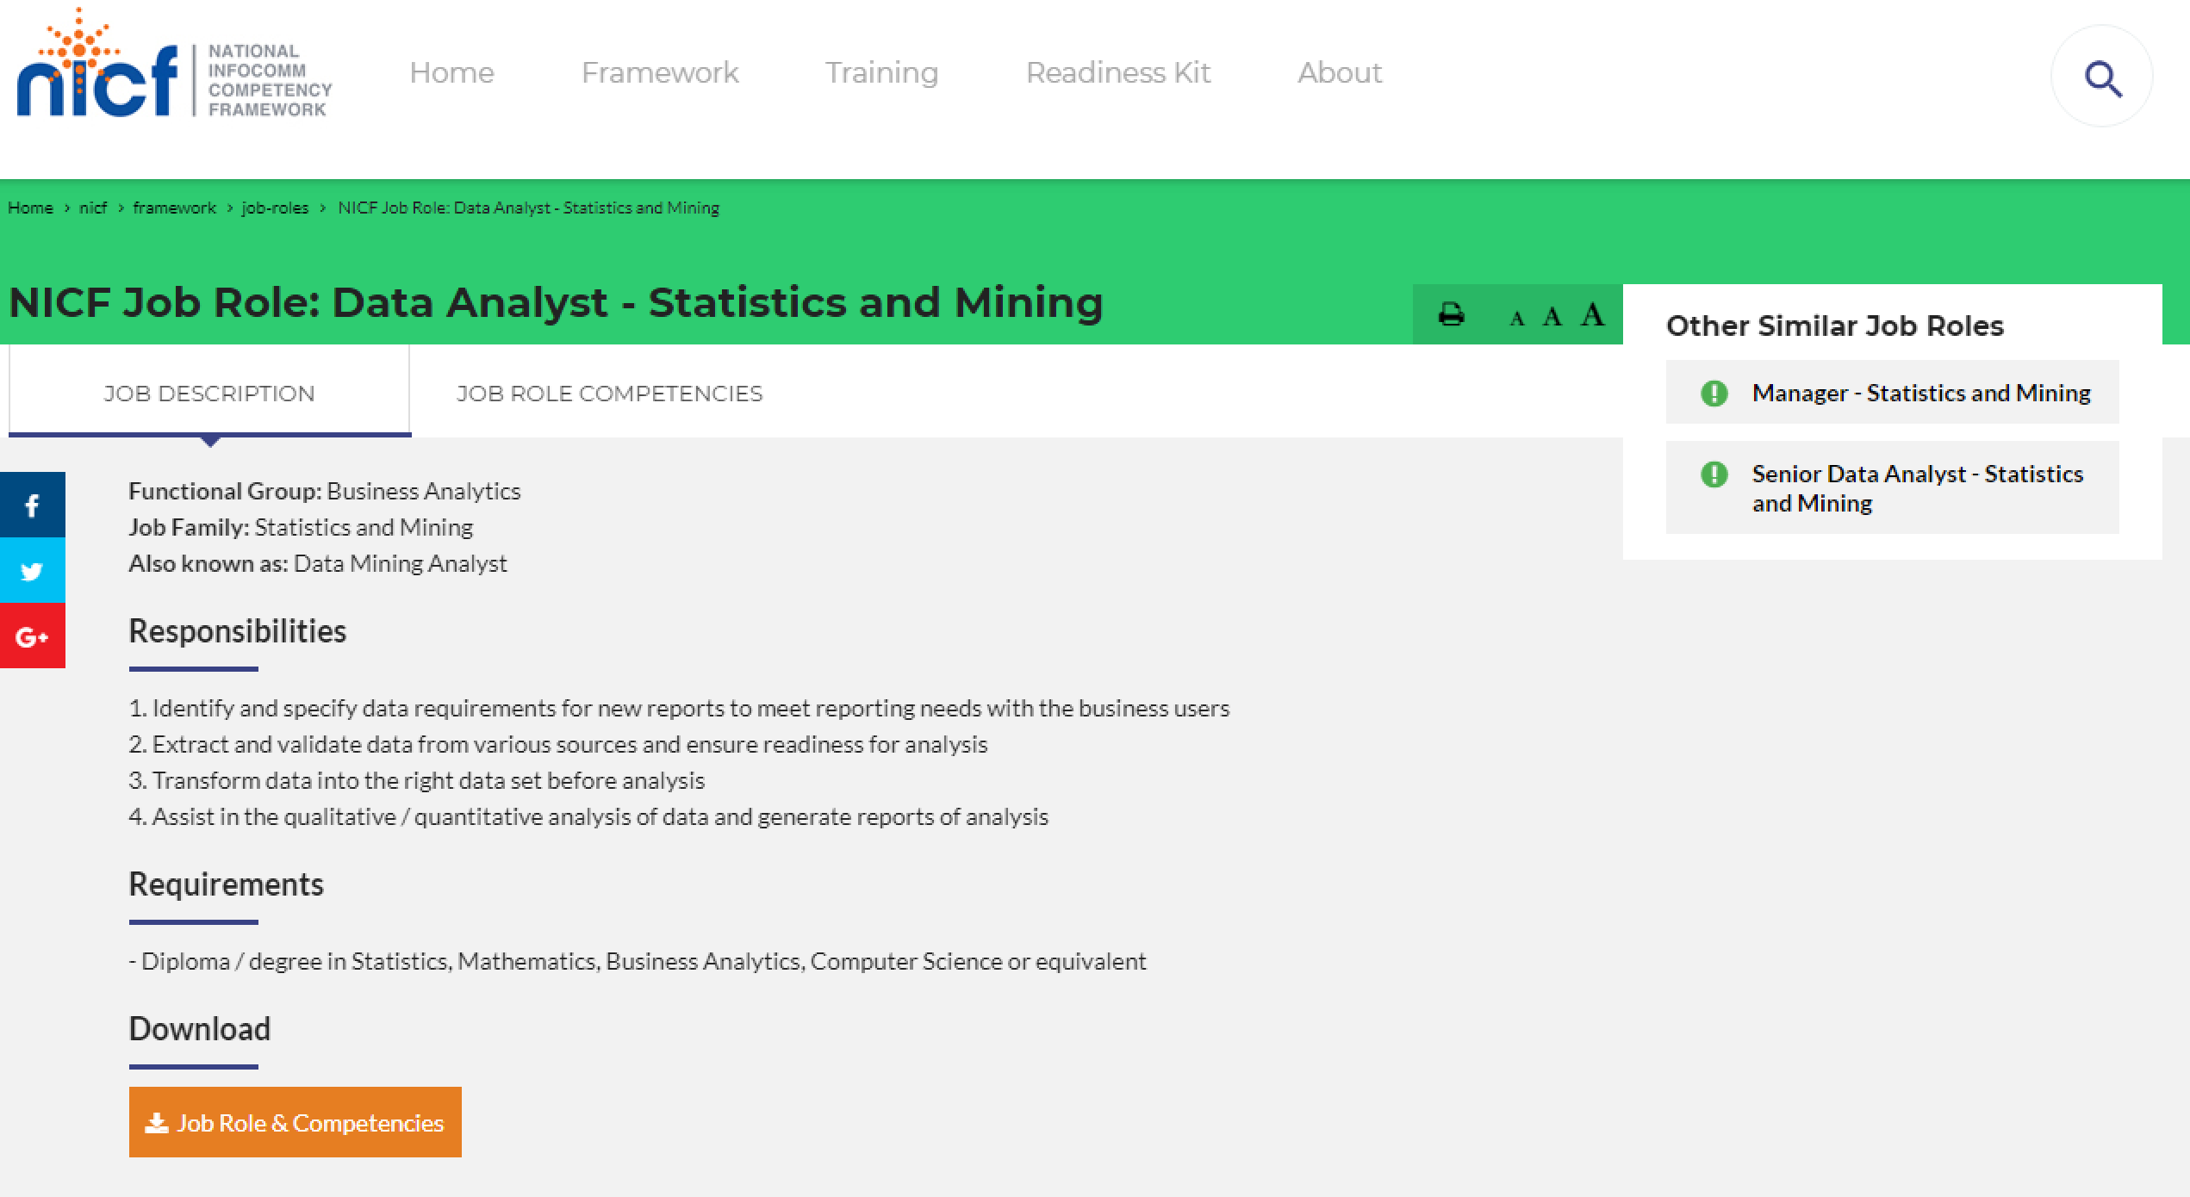

For course and Provider:

